To provide a rational foundation for gene and cell line selection, we incorporated publicly available RNA-seq data from colorectal cancer datasets. Using tools such as GEPIA and TCGA, we confirmed that MT1H, TM4SF5, BAX, and P53 exhibit differential expression in colorectal cancer tissues compared to normal controls. This validated their biological relevance in colorectal tumorigenesis. In parallel, DepMap and CCLE databases were used to characterize the genetic profiles of our selected cell lines—HCT116, HT29, and HEK293—highlighting their distinct p53 statuses and expression profiles, which made them ideal models for comparative nanoparticle toxicity studies.

In Silico Studies of Target Genes

1. Gene Expression Analysis Using GEPIA2
Gene expression profiles of TP53, BAX, MT1H, and TM4SF5 were analyzed using GEPIA2, which integrates data from TCGA and GTEx. Boxplots were generated for each gene under the colon adenocarcinoma (COAD) dataset, comparing tumor and normal tissue expression levels. TP53 and BAX were significantly upregulated in tumor samples, indicating their roles in apoptosis. TM4SF5 was also upregulated in tumors, suggesting oncogenic activity. In contrast, MT1H was downregulated, possibly due to loss of metal detoxification function in malignancy.

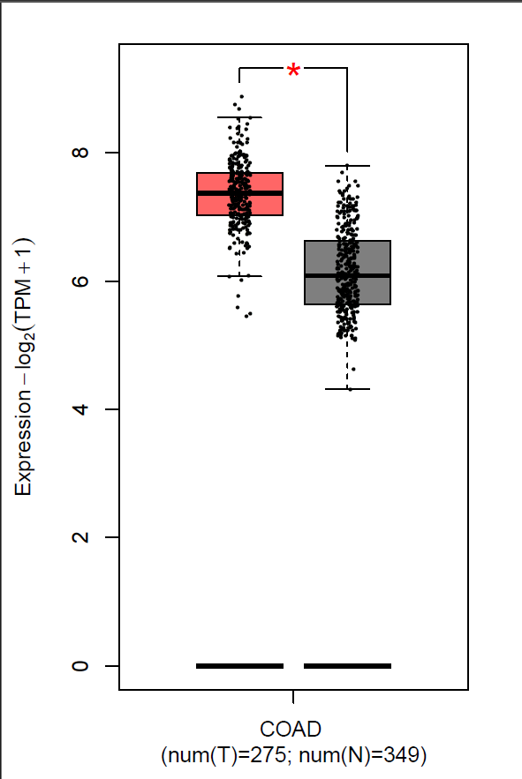
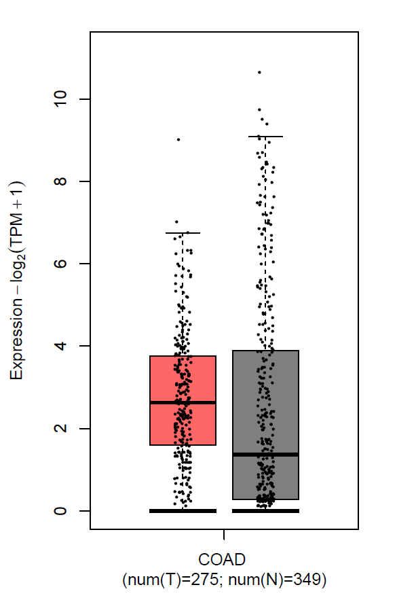
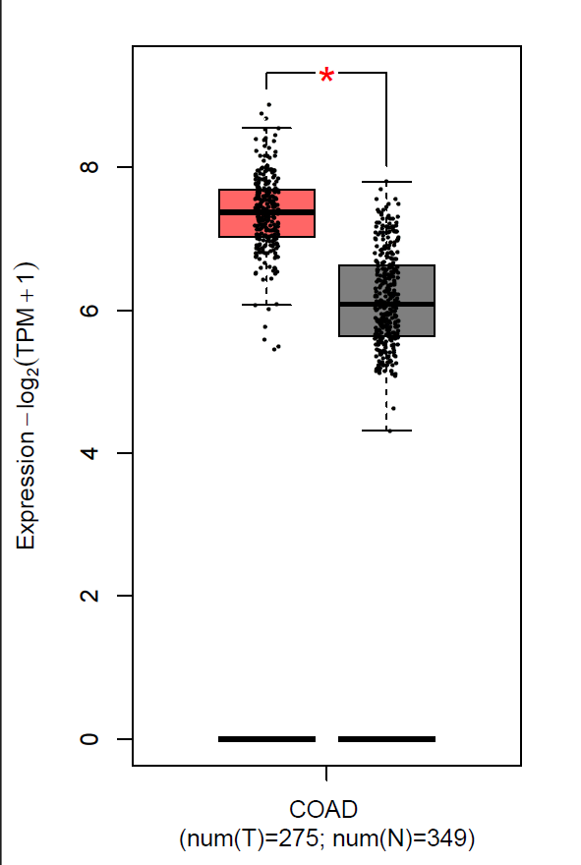
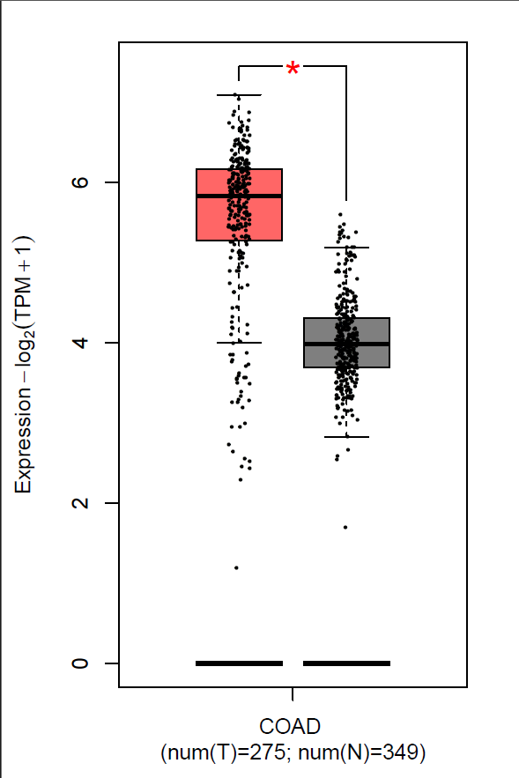
Figure X: Expression levels of TP53, BAX, MT1H, and TM4SF5 in colon adenocarcinoma (COAD) versus normal colon tissue. Gene expression data was extracted using GEPIA2 from TCGA and GTEx datasets. Red boxes represent tumor samples; gray boxes represent normal tissue. The y-axis indicates log₂-transformed transcripts per million (TPM + 1). Asterisks (*) denote statistically significant differences (p < 0.01).

2. Protein–Protein Interaction Network Using STRING
A protein–protein interaction (PPI) network was created using the STRING v11.5 database. TP53 and BAX displayed strong direct interaction, consistent with their cooperative role in regulating apoptosis. MT1H showed an indirect link to TP53, potentially via oxidative stress pathways. TM4SF5 was not functionally connected at the selected confidence level, indicating its distinct role in tumor progression. This network analysis provides a mechanistic framework to interpret gene expression changes induced by nanoparticle exposure.
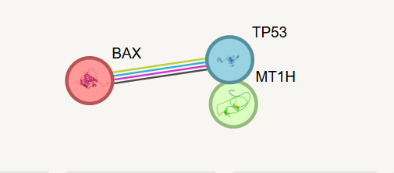
Figure 2: STRING-generated PPI network of TP53, BAX, MT1H, and TM4SF5 (confidence score ≥ 0.4). Strong edges indicate co-expression or experimentally validated interactions.

